
Gender pay gap report

Snapshot date: 31.03.2025

Difference in mean and median hourly rate of pay
 | Difference in the mean hourly pay | Difference in the median hourly pay
Pay gap. % difference male to female | 17.42 | 28.14

Difference in mean and median bonus pay
 | Difference in the mean bonus pay | Difference in the median bonus pay
Pay gap. % difference male to female | Nil | Nil

Proportion of male and female employees who were paid bonus pay
 | Proportion receiving a bonus
Male employees (% paid a bonus compared to all male employees) | Nil
Female employees (% paid a bonus compared to all female employees) | Nil

Proportion of male and female employees according to quartile pay bands
 | Quartile 1.  Lower | Quartile 2.  Lower middle | Quartile 3.  Upper middle | Quartile 4.  Upper
Male (% males to all employees in each quartile) | 12.28 | 22.81 | 21.05 | 29.82
Female (% females to all employees in each quartile) | 87.72 | 77.19 | 78.95 | 70.18

Supporting statement
I confirm that the information published here is accurate.
Signature: | 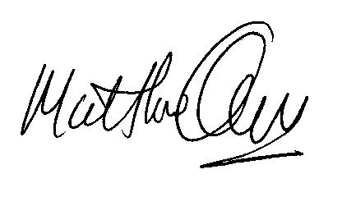 |  | Date: | 3rd March 2026
Status/position: | Chief Executive Officer
Optional supporting narrative
As an Academy Trust we are aware that the majority of our staff are female (78.51%). These females are made up of both Teaching and Support staff.

Due to the variety of roles of our female staff within school, particularly support staff, a higher percentage have a greater range of hourly pay due to their role in school compared to male employees.

We ensure that all our job roles are advertised with no gender bias resulting in fair pay in each role.

For information purposes a teachers weekly hours have been calculated using a school timetabled week which is 32.5 hours.

