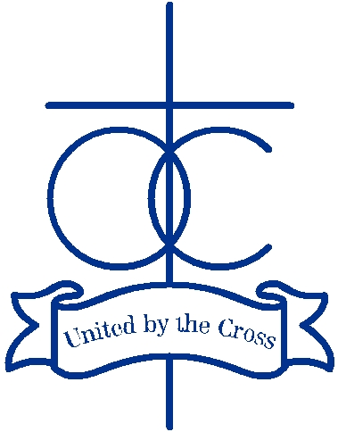 |  | 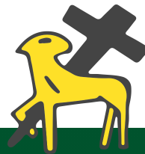
Edith Stein Catholic Academy Trust

Trust Health & Safety Policy Statement

The Board of the Edith Stein Catholic Academy Trust, hereinafter referred to as the ‘Trust’, the employer of the staff who work in its headquarters and Academies, recognises and accepts its responsibility for providing a safe and healthy environment for the staff employed in the headquarters and Academies, for the pupils attending the Academies and for visitors and contractors, who come on to the premises.

The Trust will take reasonable steps to fulfil these responsibilities within the framework of the Health and Safety at Work etc Act 1974 and the Management of Health and Safety at Work Regulations 1999 as well as those other Regulations, Approved Codes of Practice, Guidance, etc made under this legislation. The Trust will ensure that appropriate policies are in place and kept up-to-date.

To this end, the Trust will procure the services of an appropriate health and safety consultant to advise the staff of the Trust and its Academies on all related matters and to provide the Trust and the Academies with up-to-date information in relation to its health and safety responsibilities.

The responsibility for the implementation, monitoring and ongoing management of each Academy’s Health & Safety Policy within the Trust rests with the Headteachers, who are the duty holders at each site.

Each and every member of staff at the Trust and its Academies must recognise that, under the Act, they have a personal responsibility for their own safety as well as for the safety of anyone who may be affected by their acts or omissions at work. They also have to co-operate, as far as is reasonable, with their employer in fulfilling its duties under the Act and supporting legislation as well as under the Trust’s Health & Safety Policy Statement and the specific Health & Safety Policy relating to the Academy in which they work.

The specific roles, responsibilities, organisation and arrangements through which the Trust, the Academy Headteachers and staff, aim to fulfil the requirements are set out in each individual Academy’s Health & Safety Policy.

The Trust will ensure that sufficient resources are allocated by it and its Academies to ensure, as far as is reasonably practicable, that employees, pupils, visitors and contractors are kept healthy and safe.

The Trust will regularly monitor and review health & safety performance and standards at each academy within the Trust to ensure standards are continually met. A member of the Board will be nominated as the Health and Safety Lead Director/Trustee and will be responsible for ensuring all health & safety requirements are robustly monitored and effectively managed with regular reporting back to the Trust.

Signed by Chair of Board of Trustees:  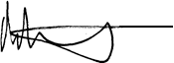 | Signed by Chief Executive Officer:  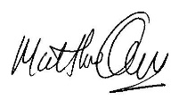
Date: 13^{h} July 2022 | Review Date: July 2023

